Firstname M. Lastname^{1,2}, Second Author^{2,3}, Third Author^{1,3} and Fourth Author¹
¹Name of affiliation institution, Address for affiliation institution
²Affiliation and address
³Affiliation and address

TITLE OF THE PRESENTATION

ABSTRACT
This document is a presentation of a proposed template for oral/poster presentation to be published for the 9th conference of the Icelandic Chemical Society. It is written in the similar style as the suggested template revision. The abstract shall reflect the content of the paper and shall be a maximum of 400 words, and no more than one page. It can be in either Icelandic or English, and you can also submit abstracts in both languages (on the same or separate page).

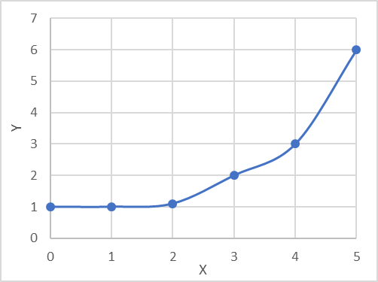
FIGURE 1: Example of figure placement and figure caption

REFERENCES
- Wright, R.; Cotner, S.; Winkel, A. Minimal Impact of Organic Chemistry Prerequisite on Student Performance in Introductory Biochemistry. CBE - Life Sci. Educ. 2009, 8, 44–54. https://doi.org/10.1187/cbe.07.
- McCoy, E. D.; Pierce, S. K. The Function of Course Prerequisites in Biology. Am. Inst. Biol. Sci. 2009, 1–17.
- Marcal, L.; Roberts, W. W. Computer Literacy Requirements and Student Performance in Business Communications. J. Educ. Bus. 2000, 75 (5), 253–257. https://doi.org/10.1080/08832320009599023.
- Zhang, G.; Thorndyke, B.; Ohland, M. W.; Anderson, T. J. How Science Course Performance Influences Student Retention - A Statistical Investigation. ASEE Annu. Conf. Proc. 2004, 6539–6548.
- ACS Style Quick Guide. In The ACS Guide to Scholarly Communication; 2020. https://doi.org/10.1021/acsguide.40303.

